Design Principles - Interface Segregation Principle (ISP)
# Source: AI Source: Provided by: [Data Path: Persons Table -> ID Column: 1, Name_En Column: Motasem Essam] -> From: [ChatGPT] on [1/23/2026]
The Interface Segregation Principle states that clients should not be forced to depend on interfaces they do not use. Large interfaces should be split into smaller, specific ones.
👉 Think of it like giving workers only the tools they need for their job, instead of making them carry an entire toolbox they won’t use.

🔑 Key Points
# Source: AI Source: Provided by: [Data Path: Persons Table -> ID Column: 1, Name_En Column: Motasem Essam] -> From: [ChatGPT] on [1/23/2026]
• Split fat interfaces into smaller, focused interfaces
• Clients depend only on the methods they actually use
• Reduces unnecessary coupling between modules
• Improves maintainability, flexibility, and readability

❌ Bad Example
# Source: AI Source: Provided by: [Data Path: Persons Table -> ID Column: 1, Name_En Column: Motasem Essam] -> From: [ChatGPT] on [1/23/2026]
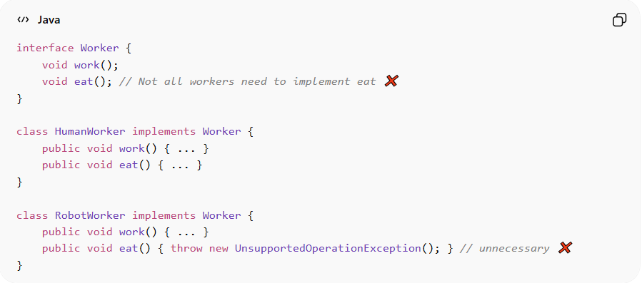
interface Worker {
void work();
void eat(); // Not all workers need to implement eat ❌
}

class HumanWorker implements Worker {
public void work() { ... }
public void eat() { ... }
}

class RobotWorker implements Worker {
public void work() { ... }
public void eat() { throw new UnsupportedOperationException(); } // unnecessary ❌
}
Problems:
• Clients are forced to implement methods they don’t need
• Violates ISP → reduces flexibility
• Makes maintenance harder
• Leads to unnecessary code or runtime exceptions

✅ Good Example
# Source: AI Source: Provided by: [Data Path: Persons Table -> ID Column: 1, Name_En Column: Motasem Essam] -> From: [ChatGPT] on [1/23/2026]
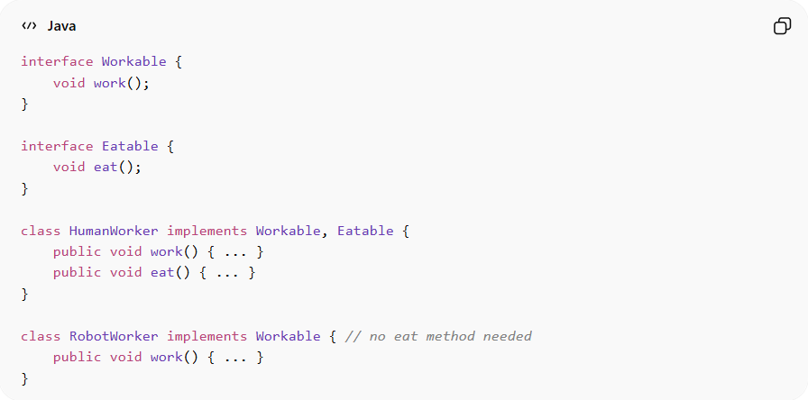
interface Workable {
void work();
}

interface Eatable {
void eat();
}

class HumanWorker implements Workable, Eatable {
public void work() { ... }
public void eat() { ... }
}

class RobotWorker implements Workable { // no eat method needed
public void work() { ... }
}
Benefits:
• Clients implement only what they actually need
• Reduces unnecessary dependencies
• Supports flexible, modular, and maintainable design
• Prevents runtime errors and unused code

⚡ When to Apply
# Source: AI Source: Provided by: [Data Path: Persons Table -> ID Column: 1, Name_En Column: Motasem Essam] -> From: [ChatGPT] on [1/23/2026]
• Always — particularly in large, interface-heavy systems
• Useful when clients have different capabilities or needs
• Works best with SRP, OCP, and high cohesion
• Supports cleaner, more modular code for reusable libraries and APIs

